**How to install, configure and add self-hosted agent in Azure DevOps?**

**Prerequisites:**

* One active Azure DevOps account
* Personal Access Token (PAT)
* One Linux instance where you will host the self-hosted agent. I am using Azure VM.

**Step 1: Login to Azure DevOps portal and click on “Organization settings”**

**Step 2: Navigate to Pipelines > Agent pools and click “Add pool”.**

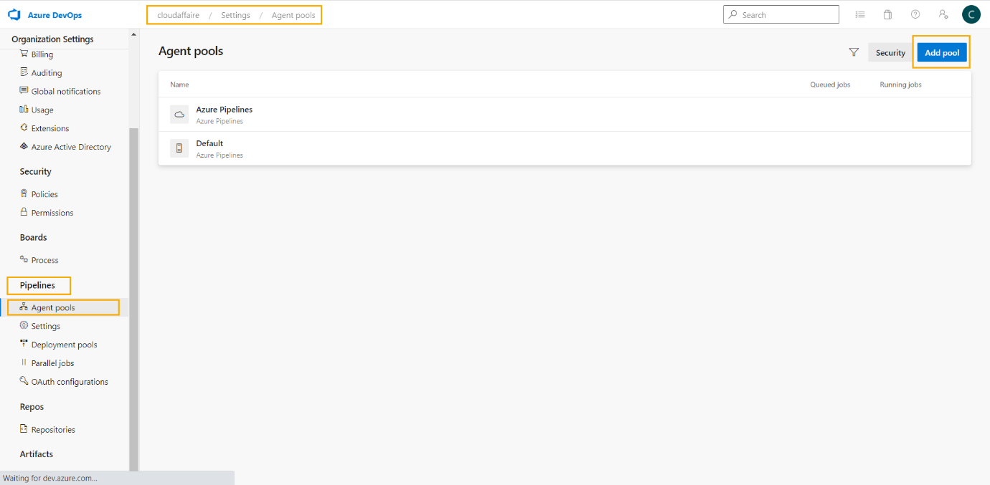

**Step 3: From the “Pool type” drop-down select “Self-hosted”, provide a name and description and click “Create”.**

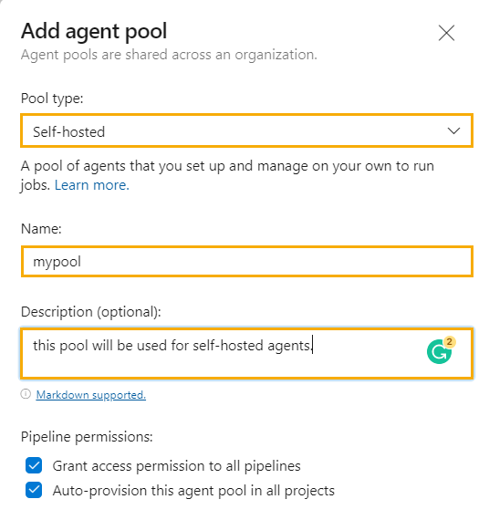

**Step 4: Click on the newly create pool and then click on “New agent”.**

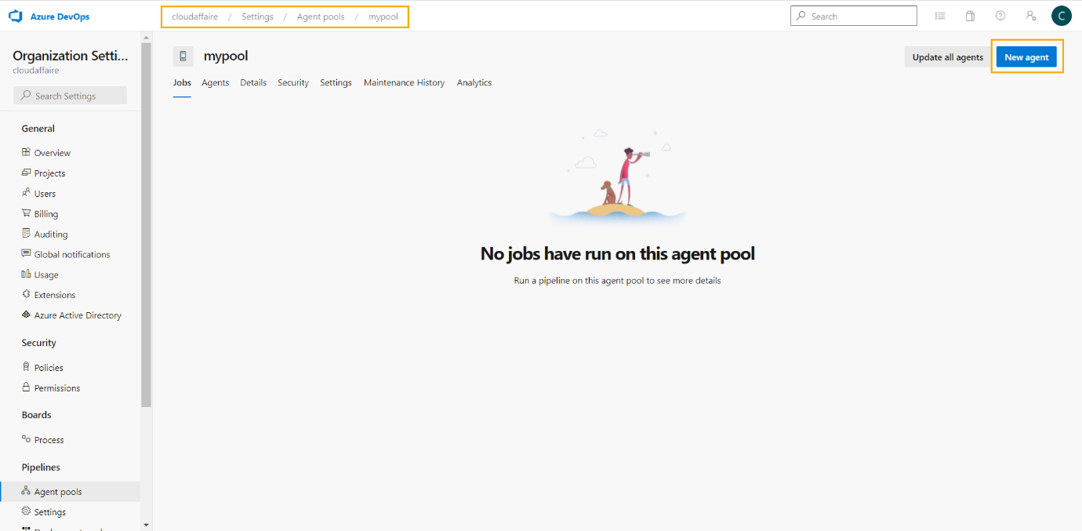

**Step 5: Select the OS and architecture and copy the download link.**

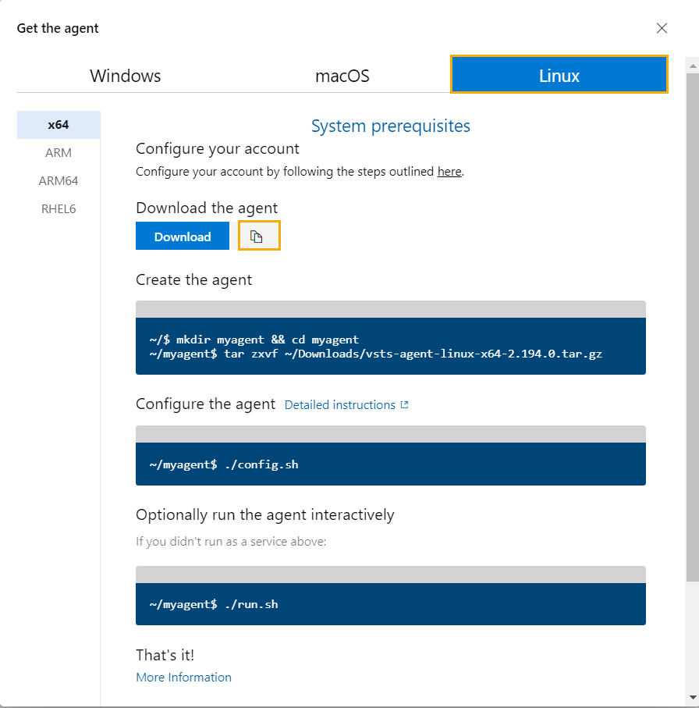

**Note**: For this demo I am using an Azure Linux VM to host the Azure self-hosted agent.

**Step 6: Install self-hosted agent on your system as per instructions in step 5.**

**Step 7: Configure and add self-hosted agent for Azure DevOps.**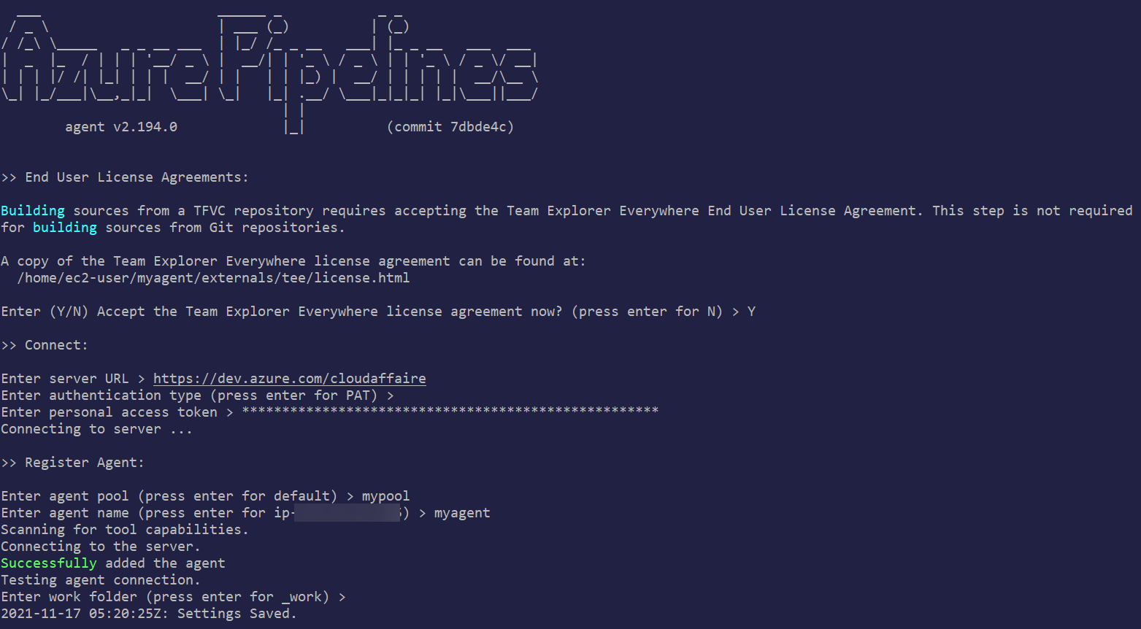

Now if you refresh the Azure DevOps agent page, this new self-hosted agent will be listed there.

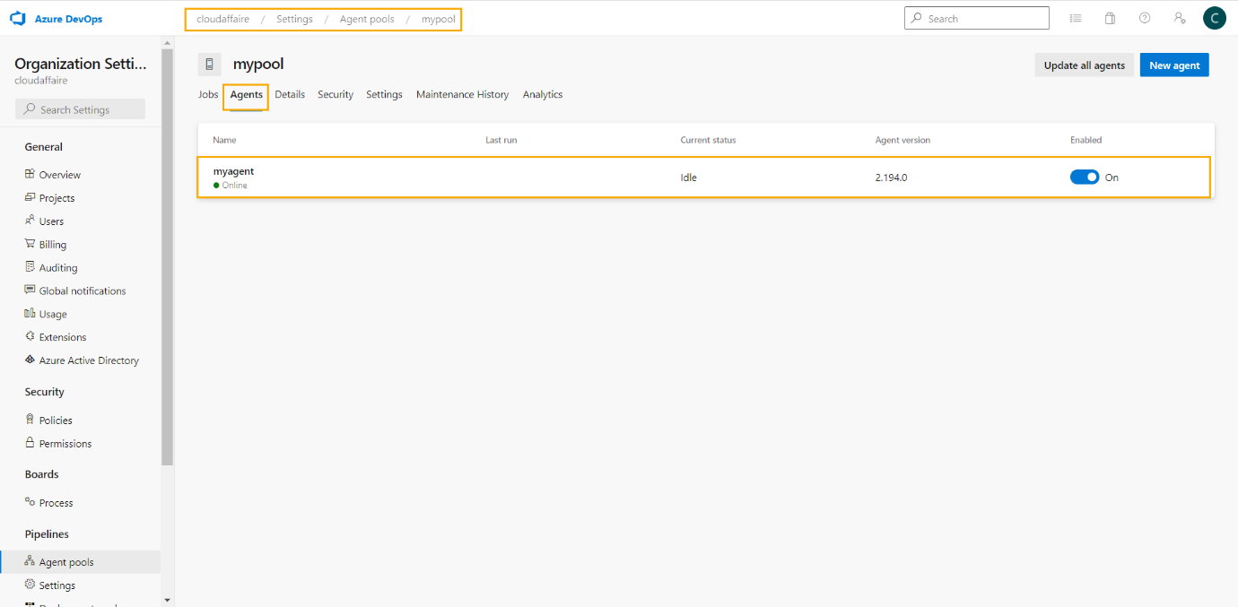

Next, we are going to test this newly deployed self-hosted agent by running a Azure Pipeline on it.

**Step 8: Create a new Azure repo in any of the project under your Azure DevOps organization and add below file in it.**

## ----------------------------

## Test Azure self-hosted agent

## ----------------------------

**## Create a new Azure repo and below file in it.**

#azure-pipelines.yml

pool: DanskeSelfHostedPoolPuneet

trigger:

branches:

include:

- '*'

stages:

- stage: Build

jobs:

- job: BuildJob

steps:

- script: echo Building!

- stage: Test

jobs:

- job: TestOnWindows

steps:

- script: echo Testing on Windows!

- job: TestOnLinux

steps:

- script: echo Testing on Linux!

- stage: Deploy

jobs:

- job: Deploy

steps:

- script: echo Deploying the code!

**Step 9: Add a new Azure pipeline inside the project where you have created the new Azure repo in the previous step.**

Navigate to “Pipelines” and click “Create Pipeline”.

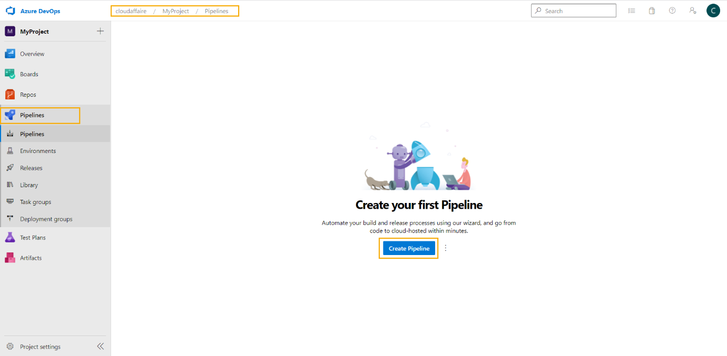

Select “Azure Repos Git”.

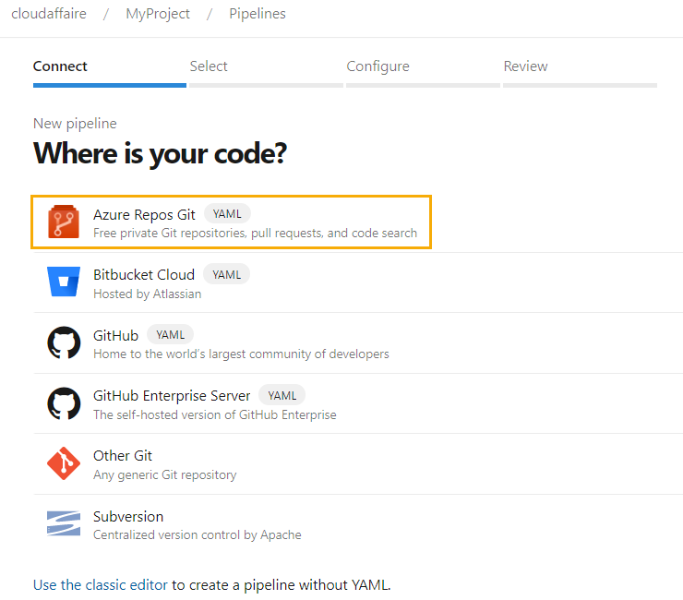

Select the repository created in step 8.

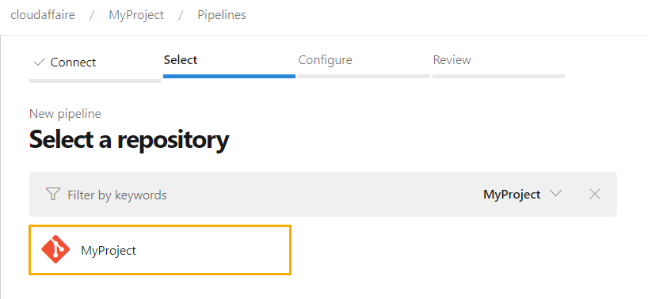

Select “Existing Azure Pipelines YAML file”.

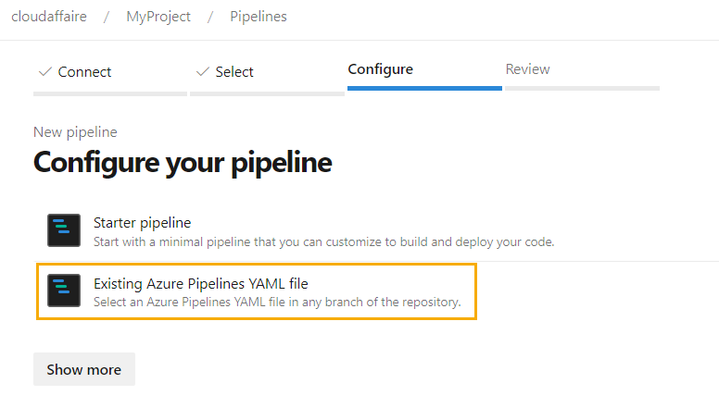

From the drop-down select your Azure repo branch and the location of the file azure-pipelines.yml and click “Continue”.

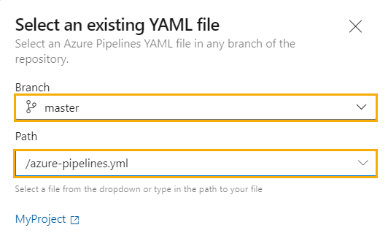

Click on “Save” to save the pipeline configuration and then click on “Run” to run the Azure pipeline manually.

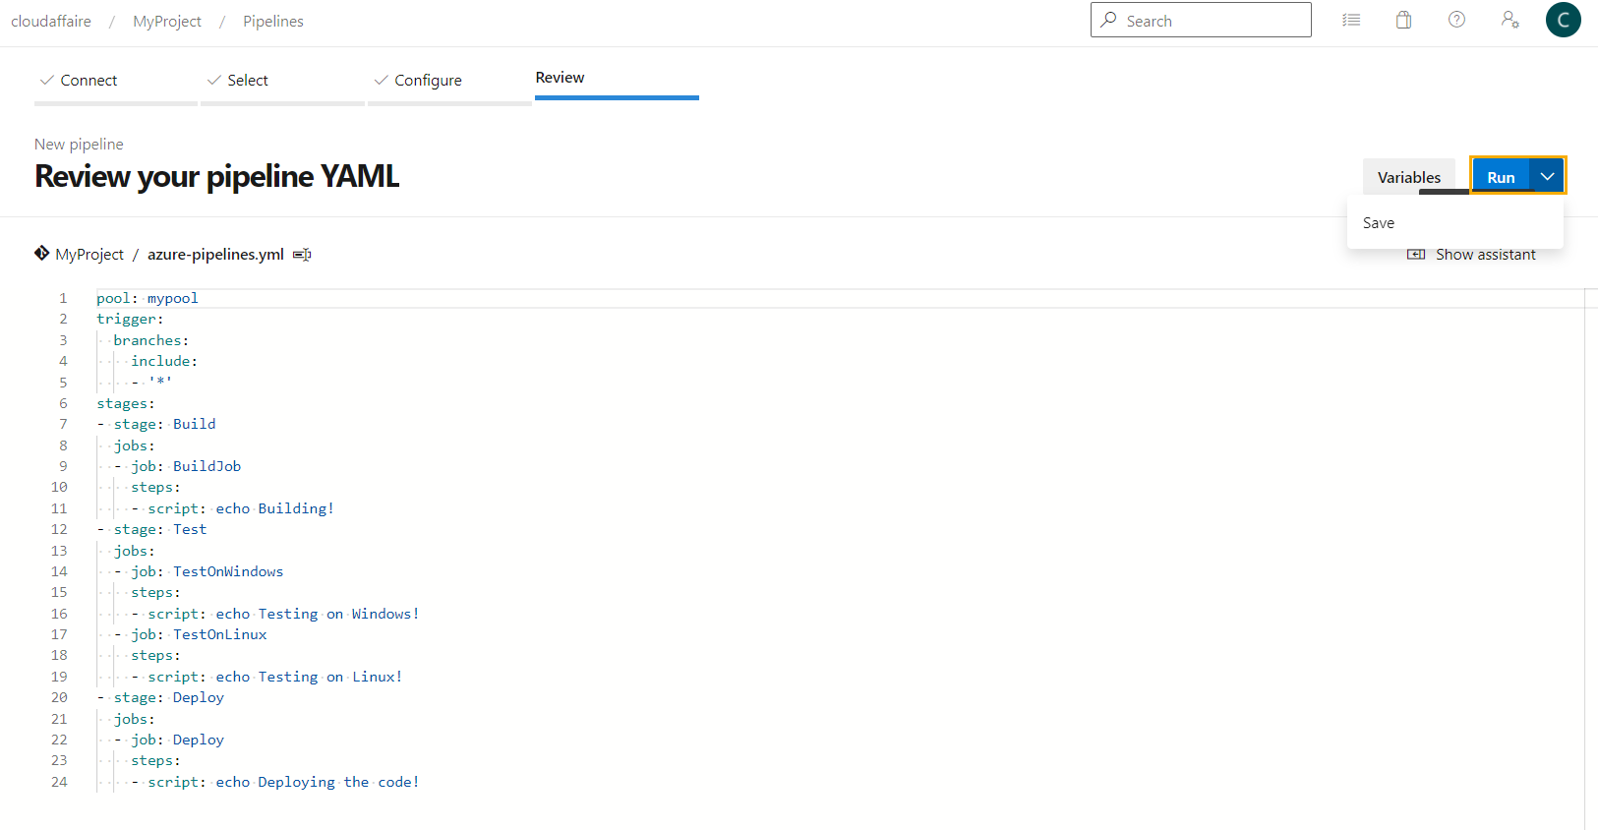

Our new Azure Pipeline gets executed successfully in our self-hosted runner.

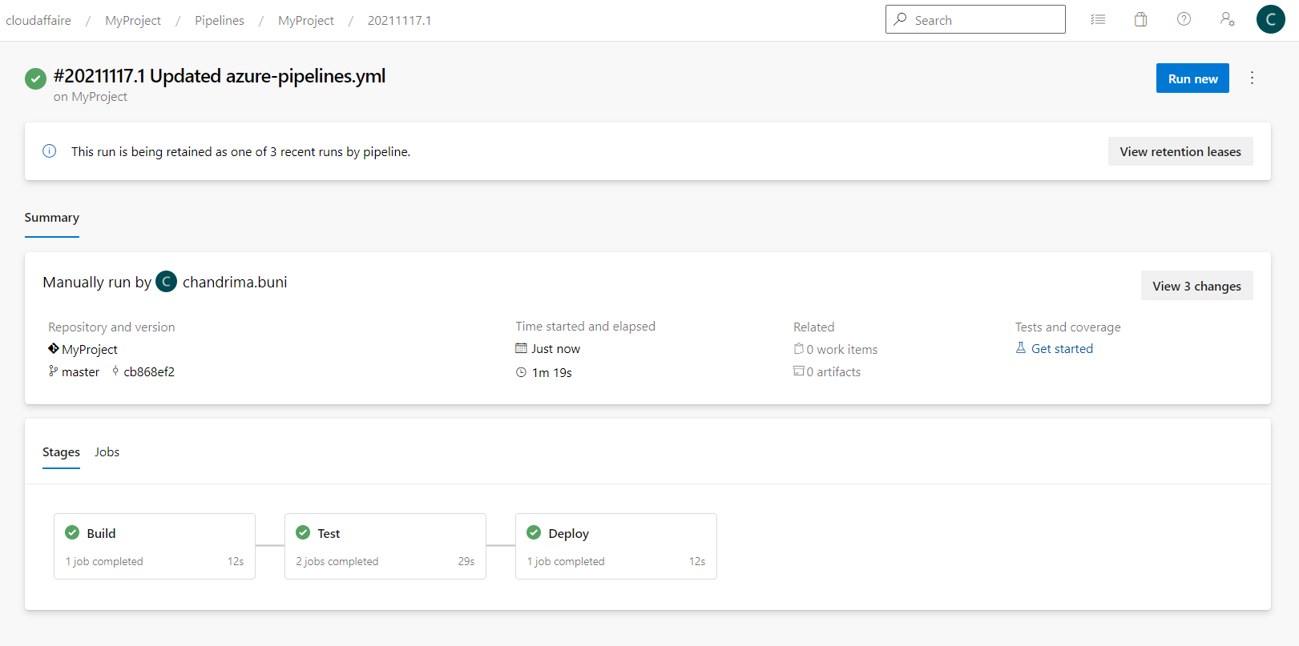

You can also view details of the execution by clicking on any stages or jobs.

